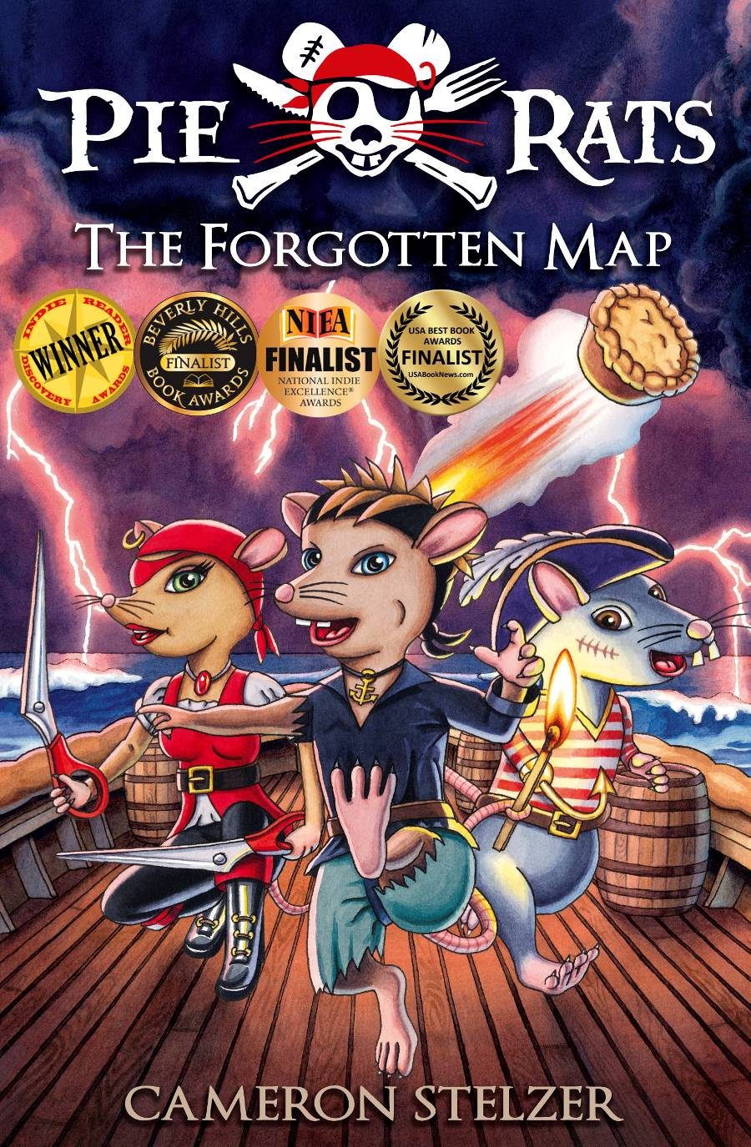

Series: Pie Rats series
Title: The Forgotten Map: Book 1
Author: Cameron Stelzer
Category: Junior Fiction
Age: 8-12 years, 272 pp
Publisher: Daydream Press
ISBN: 978-0-9874615-0-6
Introduction

The Forgotten Map is the first book in the Pie Rats series, written and illustrated by Cameron Stelzer.
Whisker is a cyclone-surviving circus rat with a troublesome tail and a boat load of luck. When a strange ship pulls him out of the ocean, Whisker’s new life as a Pie Rat apprentice begins. Welcome aboard the good ship Apple Pie – a peculiar pastry ship where cannons shoot mouldy pies, coloured pencils are used as peg-legs and the champion swords-rat fights with two scarlet scissor swords.
The Forgotten Map is an illustrated novel in the adventure/pirate genre. It includes maps, diagrams and character sketches. The action moves smoothly from one plot-propelling crisis to the next, taking the reader on a swashbuckling adventure where danger and humour intertwine in true pirate fashion. The writing style is formal, with descriptive passages running throughout the text and a focus on humorous character speech. The recommended reading age is 8-12 years.
Thematically, the book takes a look at the meaning and importance of family through the desperate eyes of a young rat who has lost everything. Sub themes include friendship, loyalty, resilience and hope unbowed by despair. Similar books include Chronicles of Narnia, the Redwall series, The Hobbit, Wind in the Willows, Deltora Quest, and the Brotherband series.
The Author
Cameron was born in Hobart in 1977. He attended school in Adelaide before his family moved to Bundaberg, QLD. In primary school, Cameron wrote many short stories for the local newspaper. He still has a shoe box of gold certificates for his efforts. In high school Cameron discovered a passion for art and chose to undertake further studies at the Queensland College of Art in Brisbane.
After complete his doctorate, Cameron went to live in London where he stumbled into a job at the Natural History Museum. It was here that he rekindled his love for children's literature and began writing stories inspired by the animals in the museum.
When Cameron returned to Australia, he completed a graduate diploma in education and released the first instalment in his Stroogle series of picture books. Eight years later, the sixth book in the series was published and followed on from three additional how-to-draw books. In 2012 Cameron received a grant to create the first book in his new Pie Rats series.
The Forgotten Map won the Kid's Fiction Prize in the Indie Reader Discovery Awards at the Book Expo of America and made IR's best books for 2014 list. Following the success of the first book in the series, The Island of Destiny won the 2015 Indie Reader Discovery Award for Kid’s Fiction and was a finalist in the Children's Fiction category of the 2015 International Book Awards.
Apart from writing and illustrating stories, Cameron spends much of his time running workshops with primary school students and touring interstate. You can also catch Cameron running through the beautiful Daisy Hill forest (South-East QLD), where he lives with his wife and three daughters.
Reading the Text
It is encouraged that teachers introduce The Forgotten Map via the book trailers available (please see www.drcameron.com.au). Also, reading the Prologue and Chapter 1 sets the scene and introduces students to Cameron’s writing style. The Prologue and Chapter 1 are provided as an Excerpt (available for download at www.drcameron.com.au). Following the introductory chapters, the teacher could continue to read the text, or ask the students to read subsequent chapters on their own.

Comprehension Questions about the Text
Students can answer these questions verbally, in pairs, or as a written task. It is recommended the questions are handed out after all students have finished the relevant chapters. For printing purposes, the questions (without answers) are listed at the end of this document.

Prologue – Chapter 5:
Q: Where was Wentworth rescued?
A: The Cyclone Sea.

Q: Why are the crew called the Pie Rats?
A: They are rats and they like pies.

Q: What does Whisker wear around his neck?
A: A gold anchor pendant.

Q: Name something strange about the construction of the Apple Pie ship.
A: Its hull resembles a giant pie. It has cutlery for masts. It has clothing and underpants for sails attached by pegs, pencils and coat hangers.

Q: What do the Pie Rats use for swords?
A: Broken scissors.

Q: Name two ingredients in the Pie Rats’ short-range cannon pies?
A: Any two of the following: Brussel’s sprouts. Blue-vein cheese. Garlic. Pastry.

Chapters 6-10:
Q: What was Whisker’s punishment for shooting the Captain?
A: He offered to wash the Captain’s clothes, scrub the deck and scrape the barnacles off the hull.

Q: What animals are on the Claw-of-War navy ships?
A: Soldier crabs.

Q: What object did the Pie Rats hit with their flying pie?
A: A small boat containing three mice.

Q: What is the name of the inn where Whisker meets Rat Bait?
A: The Captain’s Inn.

Q: What does Whisker do when Captain Sabre threatens to hurt Rat Bait?
A: He uses his tail to throw a mug of Apple Fizz in Sabre’s face.

Q: Name the two Cat Fish who trap Whisker in the ally.
A: Cleopatra and Siamese Sally.
Chapters 11-15:
Q: What is the colour of Gourmet Gunpowder smoke?
A: Purple.

Q: Who kidnapped Whisker and Rat Bait in the drain?
A: The Pie Rats (Ruby, Horace, Pete and the Captain).

Q: What did the tattoo on Rat Bait’s arm symbolise?
A: The Island of Destiny (twin mountains).

Q: Who is looking after the Forgotten Map?
A: A white weasel named Madam Pearl.

Q: What is the official seal of Governor Cazban?
A: A banana.

Q: How did Whisker and Horace enter the prison?
A: By rolling their barrels through the entrance gates and crashing into the Gatekeeper.

Chapters 16-19:
Q: How did Horace escape from the cell?
A: Using a skeleton key hook attachment hidden in his boot.

Q: What attacked the Pie Rats at the top of the Prison Island tower?
A: A giant spider crab.

Q: How did the Pie Rats start a fire at the tower door?
A: By burning their oil-soaked coats with a flaming torch.

Q: Name two wishes Madam Pearl promised to grant the Pie Rats.
A: Any two of the following: The entry fee for the Pirate Cup. Weapons, ammunition and supplies for the tournament. A new skeleton key for Horace. The location of the Forgotten Map.

Q: What is the name of the Cat Fish ship?
A: The Silver Sardine.

Q: What do the Cat Fish shoot from their cannons?
A: Flaming fur-balls.

Chapters 20-22:
Q: What disguise did Whisker wear to sneak into Port Abalilly?
A: He was dressed as a bag-carrying bellboy (Red coat with gold buttons, black trousers and a red cap).

Q: Why does Ruby wear an eye patch?
A: Because she was blinded in the plague when her family died. It helps her to hide her past.

Q: How did Whisker and his companions get past the Blue Claw patrol?
A: They climbed up a drainpipe and crept along the roof.

Q: Name the shop where Whisker found the Forgotten Map.
A: The Portside Boutique.

Q: What made the sniffer hound’s nose hurt?
A: Strong perfume.

Q: What shape is the hole in the Forgotten Map?
A: Key shaped.

Creative Activities (after reading the text)

- Creative Writing
  - The Forgotten Map begins with a cyclone. Write a short descriptive passage about another natural disaster and its impact on people or animals.
  - In the story, Wentworth is separated from his family. Write a paragraph exploring what you would miss most about your own family (e.g. Mum’s cooking).
  - Write a diary entry for a day spent on the Pie Rats’ ship the Apple Pie.
  - Write a strong opening topic sentence anticipating what the Pie Rats might discover on the Island of Destiny.
  - For character development, describe one new Pie Rat character (or another animal pirate), listing at least 10 characters traits (including their looks, personality, likes/dislikes, quirky and memorable behaviours etc).

- Art and Illustration
  - Draw a picture of Pete’s cabin, based on the description in Chapter 1.
  - Draw or paint your favourite character from the story.
  - Create your own animal pirate crew, followed by a drawing of a unique pirate ship and flag. Consider what the characters could use instead of wooden legs, hook hands etc.
  - For pirate themed activities, please visit http://drcameron.com.au/resources.html for the following templates which can be downloaded as one document:
    - Create A Pie Rat Ship
    - Create A Pirate Flag
    - Create Your Own Treasure Map
    - Talk Like A Pirate words
    - Newspaper Pirate Hat

- Music and Performance
  - Host a pirate dress-up day and assist students to talk and look like a pirate using the downloadable documents.
  - The Pie Rats recite their own battle chant on page 83 of the story. Students can create a chant for their own characters.

- Discussion Topics and Class Projects
  - The Pie Rat crew have a Pie Rat Code, listed on page 33. What ‘codes’ or list of rules apply in our society and in our different environments? E.g. within the family, school, country etc. Create a class ‘Pirate Code’ poster.
  - Research traditional roles on pirate/ sailing ships. Each student can create their own pirate name using alliteration and assign themselves a position in the class crew.

Further Reading and Information

Titles in the Pie Rats series (in reading order):
The Forgotten Map
The King’s Key
The Island of Destiny
The Trophy of Champions
Child of the Cloud
The Golden Anchor

For further information about books and the workshops that Cameron delivers in primary schools, please visit www.drcameron.com.au.

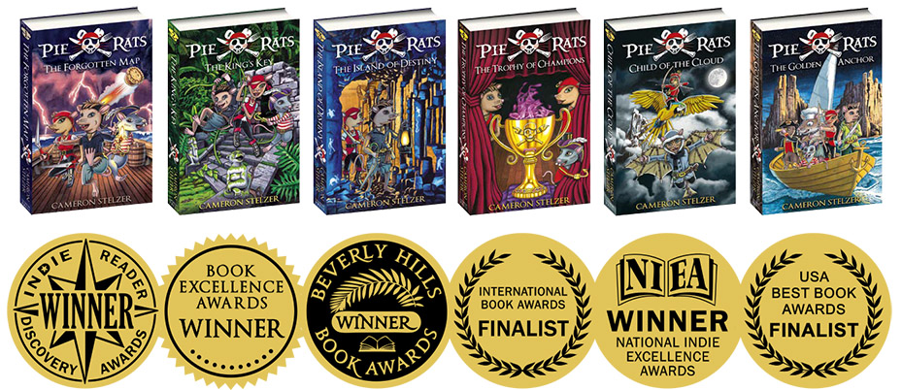

Comprehension Questions – for students

Prologue – Chapter 5:

Q: Where was Wentworth rescued?

Q: Why are the crew called the Pie Rats?

Q: What does Whisker wear around his neck?

Q: Name something strange about the construction of the Apple Pie ship.

Q: What do the Pie Rats use for swords?

Q: Name two ingredients in the Pie Rats’ short-range cannon pies?

1.

2.

Chapters 6-10:

Q: What was Whisker’s punishment for shooting the Captain?

Q: What animals are on the Claw-of-War navy ships?

Q: What object did the Pie Rats hit with their flying pie?

Q: What is the name of the inn where Whisker meets Rat Bait?

Q: What does Whisker do when Captain Sabre threatens to hurt Rat Bait?

Q: Name the two Cat Fish who trap Whisker in the ally.

1.

2.

Chapters 11-15:

Q: What is the colour of Gourmet Gunpowder smoke?

Q: Who kidnapped Whisker and Rat Bait in the drain?

Q: What did the tattoo on Rat Bait’s arm symbolise?

Q: Who is looking after the Forgotten Map?

Q: What is the official seal of Governor Cazban?

Q: How did Whisker and Horace enter the prison?

Chapters 16-19:

Q: How did Horace escape from the cell?

Q: What attacked the Pie Rats at the top of the Prison Island tower?

Q: How did the Pie Rats start a fire at the tower door?

Q: Name two wishes Madam Pearl promised to grant the Pie Rats.

1.

2.

Q: What is the name of the Cat Fish ship?

Q: What do the Cat Fish shoot from their cannons?

Chapters 20-22:

Q: What disguise did Whisker wear to sneak into Port Abalilly?

Q: Why does Ruby wear an eye patch?

Q: How did Whisker and his companions get past the Blue Claw patrol?

Q: Name the shop where Whisker found the Forgotten Map.

Q: What made the sniffer hound’s nose hurt?

Q: What shape is the hole in the Forgotten Map?

